**Bring your next great idea to life with the Azure free account**

* ₹13,300 in credit for 30 days to explore any combination of Azure services.
* 12 months free access to compute, storage, database and networking services.
* More than 25 always-free services.

**Change your Azure account profile information such as contact email, address, and phone number**

The email address in the Account Administrator’s profile is used by Microsoft to notify you about important billing-related updates about the subscription. We recommend that you specify a contact email address that you check regularly.

## How to change your profile information

1. Sign in to the [Azure Account Center](https://account.azure.com/Profile).
2. Select the **Edit details** button, and then update the **Profile** information.

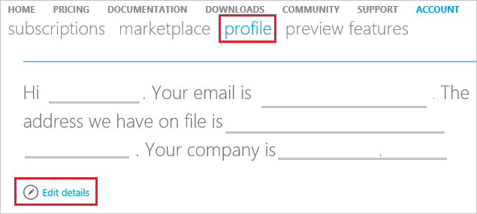

## Frequently asked questions

### Can notifications be sent to a different email address other than the Account Administrator email address associated with my account?

Yes. The email address on the account gets important notifications about all the subscriptions under the account. So we recommend that you specify a contact email address that the Account Administrator checks regularly.

### Can I change the Account Administrator email address in my profile?

Yes. The Account Administrator is the person who set up the Azure account and who receives important email notifications about all the subscriptions under the account. We recommend that you specify a contact email address that the Account Administrator checks regularly.

### Does updating my profile email also update my login email address?

No. Updating the profile email address does not update your login email address. To change your login email address, you have to transfer ownership of the account.

### Does updating my profile address also update my credit card billing address?

To learn how to update your billing information, see [Change the credit card used to pay for an Azure subscription](https://docs.microsoft.com/en-us/azure/billing/billing-how-to-change-credit-card).

### Why can’t I update the country?

Because of technical constraints, we cannot change the country on an existing account. However, you can create an account in the desired country and then contact Azure support to migrate your services to that account.

# View all your billing accounts in Azure portal

Billing accounts define your Azure billing relationships. You can have multiple billing accounts. For example, you might have an Azure subscription that you use for personal projects. You could also have access to Azure through your organization's Enterprise Agreement. Go to [Cost Management + Billing](https://portal.azure.com/#blade/Microsoft_Azure_Billing/BillingMenuBlade/Overview) in the Azure portal to view all your billing accounts.

Currently you can only view your personal and Enterprise Agreement billing accounts. By default, the [Cost Management + Billing](https://portal.azure.com/#blade/Microsoft_Azure_Billing/BillingMenuBlade/Overview) page shows your personal billing account. However, you can navigate to **Billing accounts** and change the account.

For personal billing accounts, you can manage and view all your charges in the [Azure portal](https://portal.azure.com/). However, for Enterprise Agreement accounts, you can only view reserved instance purchases, balance, and month-to-date charges. These Enterprise agreement features are in preview and are available only if you are in an Enterprise administrator role.

## Change billing account view

1. Log in to the [Azure portal](https://portal.azure.com/).
2. From left-hand side of the portal, select **Cost Management + Billing**.
3. By default, if you have one, you see your personal billing account. If you don't have a personal billing account or you want to change to an Enterprise Agreement account, select **Billing accounts**.
4. Select an account to view details. For Enterprise Agreements, you will only see the billing accounts, where you are an Enterprise administrator. Other Enterprise Agreement roles will be supported in the future.

